Server Output

Select operation mode (Server = 1, Peer = 2): 1
This process will operate as the Server.

Select the port that will be used for listening: 2000

The server is now active.
Peer 1 has connected!
Peer 2 has connected!
Updating file index, adding: peer2file9
Updating file index, adding: peer2file10
Updating file index, adding: peer2file4
Updating file index, adding: peer2file2
Updating file index, adding: config
Updating file index, adding: peer2
Updating file index, adding: peer2file8
Updating file index, adding: peer2file3
Updating file index, adding: peer2file6
Updating file index, adding: peer2file1
Updating file index, adding: peer2file7

***NEW INDEX***
peer2file9
peer2file10
peer2file4
peer2file2
config
peer2
peer2file8
peer2file3
peer2file6
peer2file1
peer2file7
**************

Updating file index, adding: peer1file7
Updating file index, adding: peer1file4
Updating file index, adding: peer1file9
Updating file index, adding: peer1file3
Updating file index, adding: peer1file10
Updating file index, adding: peer1file6
Updating file index, adding: peer1
Updating file index, adding: peer1file2
Updating file index, adding: config
Updating file index, adding: peer1file5
Updating file index, adding: peer1file8

***NEW INDEX***
peer2file9
peer2file10
peer2file4
peer2file2
config
peer2
peer2file8
peer2file3
peer2file6
peer2file1
peer2file7
peer1file7
peer1file4
peer1file9
peer1file3
peer1file10
peer1file6
peer1
peer1file2
config
peer1file5
peer1file8
**************

These peer ID(s) have peer1file7: 1

Peer Output

Select operation mode (Server = 1, Peer = 2): 2
This process will operate as a Peer.

Select the IP address to connect to:
Connection Established!

Please enter a command (Use ? for help): registry

1
Adding file information to indexing server...
Updating file index, adding: peer2file9
Updating file index, adding: peer2file10
Updating file index, adding: peer2file4
Updating file index, adding: peer2file2
Updating file index, adding: config
Updating file index, adding: peer2
Updating file index, adding: peer2file8
Updating file index, adding: peer2file3
Updating file index, adding: peer2file6
Updating file index, adding: peer2file1
Updating file index, adding: peer2file7
Operation complete.

Please enter a command (Use ? for help): obtain
Enter the file you are trying to obtain: peer1file7

Spring:
A hill without a name
Veiled in morning mist.
peer1file7 has been copied.
Please enter a command (Use ? for help): quit
The client has disconnected.

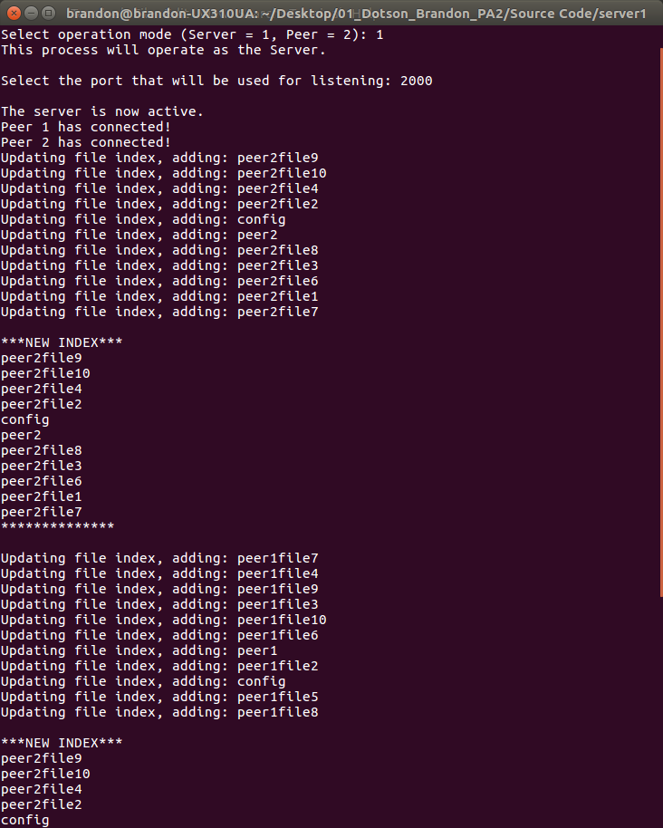
Figure 1: Server Output

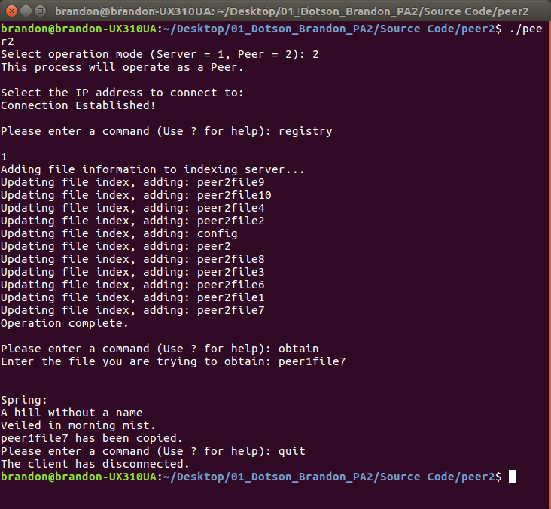
Figure 2: Peer Output

